**‘EXPERIENCES OF IRISH MOTHER AND BABY INSTITUTIONS’ STUDY:**

**A CRITICAL ANALYSIS**

*Dr Claire McGettrick, born Lorraine Hughes*

**1. INTRODUCTION**

In December 2024, the University of Limerick (UL) [announced the launch](https://www.ul.ie/news/university-of-limerick-launches-major-new-study-on-experiences-of-irish-mother-and-baby) of a ‘major new study’ entitled ‘Experiences of Irish Mother and Baby Institutions’ (EIMBI) (University of Limerick, 2024e). The study is funded by the Health Service Executive’s National Counselling Service (NCS), and also appears to be part of a larger [project](https://growth-ul.wixsite.com/psychology) which is funded by a European Research Council (ERC) Advanced Grant (Moroney et al., 2025; The GroWTH Lab, 2021a; 2021b; University of Limerick, 2024e).[1] According to the researchers, the key purpose of the EIMBI project is to ‘document the social, psychological and health needs of those with experiences of Irish Mother and Baby institutions’ (University of Limerick, 2024e). Considering its intended purpose, and the fact that there is a dearth of academic research on this subject in Ireland, the study should arguably be welcomed. However, an examination of the publicly available information about the project raises significant concerns which are addressed in the analysis of this paper.

The purpose of this analysis is threefold. Most importantly, it provides people affected by the subject matter of the study with a critical analysis to assist their understanding of the project and its potential findings. Additionally, this paper provides legislators and policymakers with additional context within which the project’s future findings can be interpreted. Finally, the analysis is a contribution to scholarship on adoption, as a constructive approach to highlight ethical issues about unintended consequences of research paradigms in the adoption field.[2] I have also aimed to make the paper accessible to as wide a public as well as academic audience by providing explanatory footnotes where necessary, and hyperlinks to relevant materials where possible.[3]

The arguments in this paper are grounded in several perspectives. First, as an adopted person who grew up under Ireland’s closed, secret, ‘clean break’ adoption system, my lived experience is a cornerstone of every aspect of my work. Second, I have been an activist and advocate in this area for over two decades. During this time, we in [JFM Research](http://www.jfmresearch.com/) (JFMR)[4] and the [Clann Project](http://www.clannproject.org/) have gathered thousands of pages of documentary evidence and witness testimony from people affected by [forced family separation, the Mother and Baby Homes](http://www.clannproject.org/), [Magdalene Laundries and other institutions](http://www.jfmresearch.com/).[5] As Co-Director of [Adoption Rights Alliance](http://www.adoption.ie/) (ARA), over the past sixteen years I have jointly managed the organisation’s [online peer support group](https://www.facebook.com/groups/adoptionrightsalliance) for people affected by forced family separation (Adoption Rights Alliance, 2009).[6] The people who have generously shared their experiences with us, whether through witness testimony or through their contributions in peer support settings, offer compelling evidence of their past experiences of human rights violations. They also provide important insights into the ongoing injustices and evolving issues relating to their experiences of forced family separation and/or institutionalisation. Through our work, my colleagues and I are privileged to have continued, regular contact with affected people. Thus, we have long-term relationships and know these individuals as valued collaborators who work with us to achieve justice and accountability, and as people with lives beyond what happened to them. This analysis is heavily informed by each of these diverse forms of engagement with affected people.

Finally, this paper is also grounded in an academic perspective. In 2011, I took the decision to enter the world of academia because my personal experience, activism and advocacy work led me to recognise the bodies of expert knowledge on adoption as lacking in several respects and I wanted to make a critical contribution to those discussions. Last year, I completed my Irish Research Council-funded doctoral research at the School of Sociology in University College Dublin. My dissertation, entitled [*Making Up Adopted People: Pathologisations in Adoption Psychology and the Shaping of Adoption Policies and Identities*](https://criticaladoptiontheory.com/makingupadoptedpeople/), sets out a critical analysis of the construction, contestation and circulation of a particular kind of expert psychological knowledge concerning adopted people (McGettrick, born Lorraine Hughes, 2024; 2025b). Drawing from critical perspectives on the psychological sciences, the study examines how adopted people came to be studied as objects of knowledge, and considers how this knowledge is mobilised in policy and practice. It also explores how adopted people interact with expert knowledge, and the ways it influences how they construct their identities and conceptualise their experiences.

This paper is comprised of four main parts. **Section 2** explores the purpose of the EIMBI study. **Section 3** discusses issues relating to exclusion, as well as questions concerning the validity of participants. Using a selection of examples, **Section 4** examines issues involving the EIMBI survey questions. Finally, in **Section 5**, I discuss the impact of expert knowledge on affected people’s lives.

**2. WHAT IS THE PURPOSE OF THE EIMBI STUDY?**

**2.1 Informing Policy and Service Development**

The EIMBI [Volunteer Information Sheet](https://criticaladoptiontheory.com/wp-content/uploads/2025/02/UL-Study_Volunteer-Information-Sheet_Redacted.pdf) tells participants that the study ‘looks at the impact [of Mother and Baby institutions] on mothers and adult adoptees’ (University of Limerick, 2024g). [According to](https://www.ul.ie/news/university-of-limerick-launches-major-new-study-on-experiences-of-irish-mother-and-baby) the project’s Principal Investigator, Professor Orla Muldoon, ‘some mothers and adult adoptees may experience ongoing … consequences’, and thus, the study aims to ‘document the social, psychological and health needs of those with experiences of Irish Mother and Baby institutions’ (University of Limerick, 2024e). Muldoon explains that ‘it is important … to make sure that those who experienced these institutions are adequately supported’. Mary Kilcommins Greene of the NCS, which funds the project, argues that the ‘experiences of mothers and adoptees are not well understood. … We are encouraging people to give their views to inform service development and policy’ (University of Limerick, 2024e).

The above statements from the EIMBI researchers and their funders raise particular issues in two key respects. **First, I am concerned that the study’s focus on ‘social, psychological and health needs’ runs the risk of creating a misconception that these are the only supports required by affected people** (University of Limerick, 2024e). **In fact, the requirements of people affected by so-called ‘historical’ abuses are diverse, and there is no universal form of remedy or reparation.** The Clann Project’s [recommendations](https://clannproject.org/restorative-recognition-scheme/clann-project-recommendations-on-restorative-recognition-scheme/) on the required measures of redress are informed by comprehensive, long-term engagements with affected people (McGettrick and O’Rourke, 2021: 2).[7] As outlined in those recommendations, at a minimum, the State redress scheme should include unfettered access to all records, a comprehensive healthcare package (including counselling), financial compensation, rights for people adopted overseas, access to the courts, investigation of deaths, and an official acknowledgement of human rights violations (McGettrick and O’Rourke, 2021: 5).[8]

**Simply put, measures to ensure truth and accountability (including access to records) are of equal importance to, and indeed have a direct bearing on, the mental and physical health of adopted people and mothers.** Indeed, the lack of access to records and exclusions from measures of redress and accountability are the primary cause of frustration, because they perpetuate past injustices. For example, the [OAK consultation](https://assets.gov.ie/285098/65cf6ce2-a60b-432b-abc5-cbbc9b7a6162.pdf) reported that for their participants, family separation represents the primary harm for which reparation is required, and the issue of access to records ‘overshadowed all others in relation to ensuring access to the [redress] scheme’ (O’Kennedy, 2021: 12, 29). Expert knowledge that does not reflect the diverse nature of affected people’s experiences and requirements is in danger of reinforcing damaging stereotypes and inaccurate narratives about these individuals (See also further discussion in **Sections 4** and **5**.)

**A second issue raised by the EIMBI statements is that it is not accurate to suggest that the experiences of people affected by so-called ‘historical’ abuses are ‘not well understood’** (University of Limerick, 2024e). As discussed above, Clann’s [recommendations](https://clannproject.org/restorative-recognition-scheme/clann-project-recommendations-on-restorative-recognition-scheme/) are comprehensive, and are informed by direct engagement with countless affected people over many years (McGettrick and O’Rourke, 2021: 2, 5). Additionally, in 2021, OAK Conflict Dynamics conducted a [consultation](https://assets.gov.ie/285098/65cf6ce2-a60b-432b-abc5-cbbc9b7a6162.pdf) on behalf of the Government, which sought the views of affected people on a proposed redress scheme and engaged with over 500 participants (O’Kennedy, 2021: 21). Moreover, in March 2024, Patricia Carey [was appointed](https://www.gov.ie/en/press-release/8bc4f-over-12900-cases-completed-under-birth-information-and-tracing-act/) as Special Advocate for Survivors of Institutional Abuse[9] (Department of Children, Equality, Disability, Integration and Youth, 2024). In a September 2024 press release to mark her first six months in post, Carey reported that at that point she had engaged with over 500 affected people from Ireland and abroad. The ‘key messages’ which affected people reported to the Special Advocate are as follows:

* Urgent need for access to records including those in private and religious ownership
* Positive response to planned National Centre for Research and Remembrance and the need for local memorialisation at all institutions
* Exclusions from and operational issues with Mother & Baby Institution payment scheme
* Supports for Survivors of Residential Institutional Abuse Bill requires speedy enactment
* Survivors feel ‘Over Consulted and Under Delivered’
* Huge desire from survivors to share their experiences of institutional abuse (Carey, 2024).

In light of the consultations and recommendations cited above, it is inaccurate to suggest that affected people’s experiences and associated requirements are ‘not well understood’ (University of Limerick, 2024e). Indeed, as indicated by the Special Advocate’s press release, if anything, these individuals feel ‘Over Consulted and Under Delivered’ (Carey, 2024).

**2.2 ERC Advanced Grant Project**

As noted in the **Introduction**, the EIMBI study appears to be part of a larger ERC-funded project, entitled ‘A Social Identity Model of Trauma and Identity Change’[10] (SIMTIC) (University of Limerick, 2024g). [According to the researchers](https://growth-ul.wixsite.com/psychology), the SIMTIC project uses a ‘social identity approach to health to examine responses to traumatic events’ (Moroney et al., 2025; The GroWTH Lab, 2021a; 2021b). The investigators state that:

This project will develop a new social paradigm for trauma research that will allow us to understand post-traumatic stress and facilitate post-traumatic resilience and growth. This new paradigm holds that changes in social identities – the sense of self we derive from being part of valued groups – are at the heart of post-traumatic outcomes. This breakthrough project will develop a synergistic model explaining how physiological, clinical, and socio-political consequences of stress and trauma result from changes in the nature, extent, and quality of social identities. Groundbreaking theory will be supported by ground-breaking methods (The GroWTH Lab, 2021a).

While the link between the SIMTIC project and the EIMBI study is referenced in academic settings (e.g., Moroney et al., 2025; The GroWTH Lab, 2021b), the survey’s [Volunteer Information Sheet](https://criticaladoptiontheory.com/wp-content/uploads/2025/02/UL-Study_Volunteer-Information-Sheet_Redacted.pdf) does not mention this relationship (University of Limerick, 2024g). This omission is concerning, because the EIMBI study’s aims are significantly different from those of the SIMTIC project, which, as noted in the extract above, aims to ‘develop a new social paradigm for trauma research’ (The GroWTH Lab, 2021a; University of Limerick, 2024e; 2024g).

**It is important that EIMBI participants understand the connection between the two projects, because at present it is not immediately clear.** At first glance, the fact that the EIMBI researchers intend to document the ‘*social, psychological* and health needs’ of affected people might suggest a potential association between that study and the SIMTIC project (University of Limerick, 2024e, emphasis added). However, the stated purpose of gathering the EIMBI survey data—*and the basis upon which participants agree to participate*—is that this data will inform policies and services: *‘We are encouraging people to give their views to inform service development and policy’* (University of Limerick, 2024e, emphasis added).

The informational materials for the EIMBI study do not indicate that participants’ data will be analysed as part of the SIMTIC project. However, a [recent article](https://bpspsychub.onlinelibrary.wiley.com/doi/10.1111/bjso.12869) published from the EIMBI study gives rise to possible concern in this respect (Moroney et al., 2025). For example, the article describes the purpose of the EIMBI study as follows:

The present study seeks to address a significant gap in the adoption literature by focusing on the role of social identity loss in the experiences of adoptees in Ireland. … In this paper, we therefore examine how social identities are shaped by the adoption process. *Specifically, we explore whether experiences of adoption-related loss can be linked to social identity changes among individuals adopted through Mother and Baby Homes in Ireland.* Our analysis will focus on how participants construct and negotiate their identities in relation to their valued social groups and other adoptees (Moroney et al., 2025: 4, emphasis added).

These aims and objectives bear no resemblance to those of the EIMBI study (University of Limerick, 2024e). However, the emphasised sentence in the extract above is strikingly similar to the following SIMTIC objective: ‘Changes in group membership and identification, and identity resources, will be linked to objective biological measures of stress and trauma’ (The GroWTH Lab, 2021a). This is a cause for concern, because although the EIMBI article is based on interviews which are distinct from the online survey, the stated purpose of these conversations (as relayed in advertisements) is identical to that of the survey (Moroney et al., 2025: 5; The GroWTH Lab, 2023). Moreover, the article acknowledges funding from the NCS (Moroney et al., 2025: 1).

As demonstrated in the advertisement at **Fig 1**, like the survey, the EIMBI interviews aimed to ‘explore [the] needs [of affected people] and discuss what is important for improving the support systems currently in place’ (The GroWTH Lab, 2023). Furthermore, the advertisement states that the research ‘will be used to inform the development of future service provisions and restorative policies for survivors’. Put simply, the study’s purpose as specified in the article is inconsistent with the information provided in the EIMBI recruitment materials (Moroney et al., 2025: 4; The GroWTH Lab, 2023). Thus, an important question arises: **can the researchers confirm that the EIMBI interview participants were provided with additional information regarding the use of their data in the SIMTIC project during the consent process?**

**Fig 1. EIMBI Advertisement for Interviews**

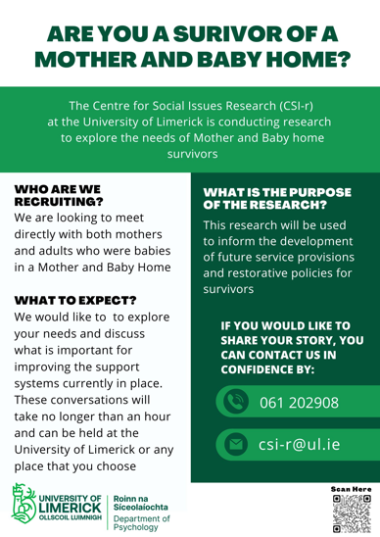

It is unclear whether the EIMBI researchers intend to analyse the survey data as part of the SIMTIC project. No such communication is provided in the study’s recruitment and informational materials. It is noteworthy that the SIMTIC project’s objectives include ‘a large-scale survey [which] will assess whether trauma, via enhanced social identification, can drive progressive social change’ (The GroWTH Lab, 2021a). Additionally, the EIMBI article referred to above argues that:

Examining social identity change through *quantitative research[11]* is therefore a crucial avenue for future studies. This would provide a systematic investigation of the links between social identity processes and the adoption experience (Moroney et al., 2025: 13, emphasis added).

Whether the EIMBI survey is the same ‘large-scale survey’ and ‘quantitative research’ referred to in the above excerpts is uncertain (Moroney et al., 2025: 13; The GroWTH Lab, 2021a). **However, if the EIMBI researchers plan to use survey participants’ data in the SIMTIC project, there is reason for concern, because the informational materials and the survey consent form do not make clear to participants that their data might be used in this way.** For example, the EIMBI [Volunteer Information Sheet](https://criticaladoptiontheory.com/wp-content/uploads/2025/02/UL-Study_Volunteer-Information-Sheet_Redacted.pdf) states that the study ‘looks at the impact [of Mother and Baby institutions] on mothers and adult adoptees’ (University of Limerick, 2024g). The Information Sheet also explains that:

The findings will be analysed and presented in an anonymous format. This will describe responses across everyone who participated, so no one’s individual responses will be examined or linked to them. The results will be presented in academic studies, through presentations and posters at academic conferences. They will also be summarised in articles for both public and academic audiences (University of Limerick, 2024g).

Similarly, on the ‘[Ethical Consent Form](https://criticaladoptiontheory.com/wp-content/uploads/2025/02/UL-Study_Consent-Form.pdf)’ participants are asked to confirm that they are aware ‘that the data will be used in future presentations and publications’ (University of Limerick, 2024g). None of this information indicates that the participants’ data might be used to ‘develop a new social paradigm for trauma research’ (The GroWTH Lab, 2021a). (See also discussions in **Sections 4** and **5**.)

**Ethically, it is imperative that scholars conducting academic research in this area ensure all informational materials make clear the ways that participants’ data may be used.** This information is crucial, as it helps people to make a decision about whether to take part, and ensures that participants’ consent is fully informed. This is important in the context of the EIMBI study, because, based on my advocacy experience, I contend that a person affected by ‘historical’ abuses is more likely to agree to participate in a study that will inform policies and services impacting their community than a project which aims to develop a new research paradigms for psychological research.

**3. STUDY PARTICIPANTS**

**3.1 Who Can Participate?**

According to the [Volunteer Information Sheet](https://criticaladoptiontheory.com/wp-content/uploads/2025/02/UL-Study_Volunteer-Information-Sheet_Redacted.pdf), the EIMBI study is investigating ‘the experiences of people who spent time in Ireland’s Mother and Baby institutions’ (University of Limerick, 2024g). That document also explains that the survey is ‘open to people who experienced forced family separation outside of these institutions’. Yet, despite this clarification, the language in the EIMBI surveys for adopted people and mothers suggests that the study’s focus appears to be solely on people who were in Mother and Baby Homes. Indeed, the phrase ‘in a Mother and Baby institution’ is repeated on numerous occasions throughout the surveys—thirty-one times in questions aimed at adopted people and thirty-six times in those asked of mothers. For example, adopted people are asked questions such as: ‘Have you ever shared your experiences of being in *a Mother and Baby institution* with others?’ (University of Limerick, 2024b, emphasis added). Similarly, in the mothers’ survey, participants are asked questions such as: ‘Have you ever shared your experiences of being in *a Mother and Baby institution* with others?’ (University of Limerick, 2024c, emphasis added).

Furthermore, as demonstrated in **Fig 2**, the first question in the survey asks participants to confirm whether they were ‘adopted through *a Mother and Baby institution*’, or if they ‘spent time in *a Mother and Baby Institution* before/during/after the birth of my child’ (University of Limerick, 2024b; 2024c, all emphasis added). There are no choices beyond the two offered, nor is there a facility to make multiple choices. **Thus, adopted people, many of whom were not born in Mother and Baby Homes, or their mothers, as well as illegally adopted people, boarded out people, or others who do not fit this description do not have an option that correctly reflects their situation.** Moreover, if such a person wants to proceed with their participation in the study, they must provide incorrect information before they can begin the survey.

**Fig 2. First Question in EIMBI Survey**

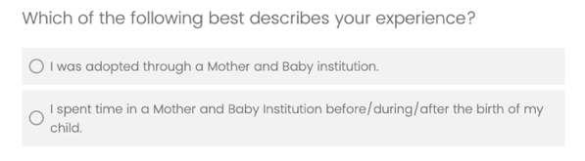

The investigators [acknowledge](https://www.ul.ie/news/university-of-limerick-launches-major-new-study-on-experiences-of-irish-mother-and-baby) that ‘forced family separation affected many outside [Mother and Baby] institutions’, and therefore, people who experienced forced family separation in other ways are permitted to participate (University of Limerick, 2024e). However, it is important to recognise that people who are affected by Ireland’s system of forced family separation and institutionalisation have been repeatedly excluded from several State investigations over the past twenty-five years. As a result of the State’s approach, the discourses surrounding Ireland’s treatment of women and children mischaracterise these abuses as (a) exclusively concerning residential or proto-carceral institutions and (b) historical (McGettrick, 2023a: 262). This serves to minimise past abuses and represents an additional injustice. **In order to avoid perpetuating exclusionary practices and the replication of inaccurate narratives, it is crucial that advocates and scholars in this field ensure that their terminology and research designs are as inclusive and sensitive as possible**. For example, in 2021, the Clann Project published [a guide](https://clannproject.org/wp-content/uploads/Clann-Project-Guide-to-Restorative-Recognition-Scheme-Consultation_17-03-21.pdf) to assist people who wished to make a submission to the [OAK Consultation](https://assets.gov.ie/285098/65cf6ce2-a60b-432b-abc5-cbbc9b7a6162.pdf) (O’Kennedy, 2021; O’Rourke and McGettrick, 2021).[12] People who wished to participate in the consultation could use the guide as a checklist or prompt to aid them in compiling their submissions. As shown in the examples at **Figs 3** and **4**, the guide offers a range of options from which participants could choose in explaining their circumstances. The guide also provides opportunities for participants to explain the kinds of human rights violations they experienced, both within and outside institutional settings (O’Rourke and McGettrick, 2021: 9-16).

**Fig 3. Extract from Clann Project Guide for Oak Consultation Participants**

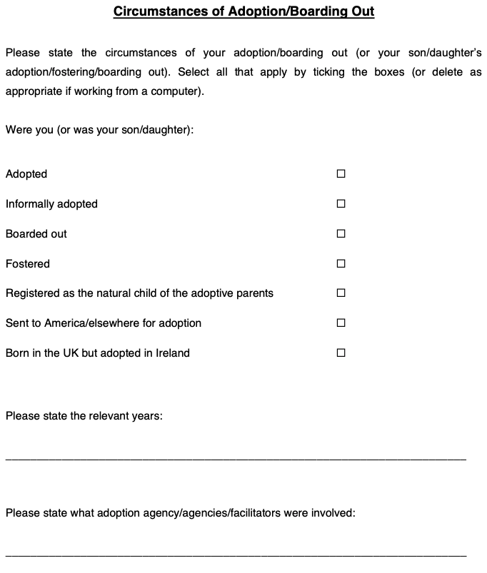

**Fig 4. Extract from Clann Project Guide for Oak Consultation Participants**

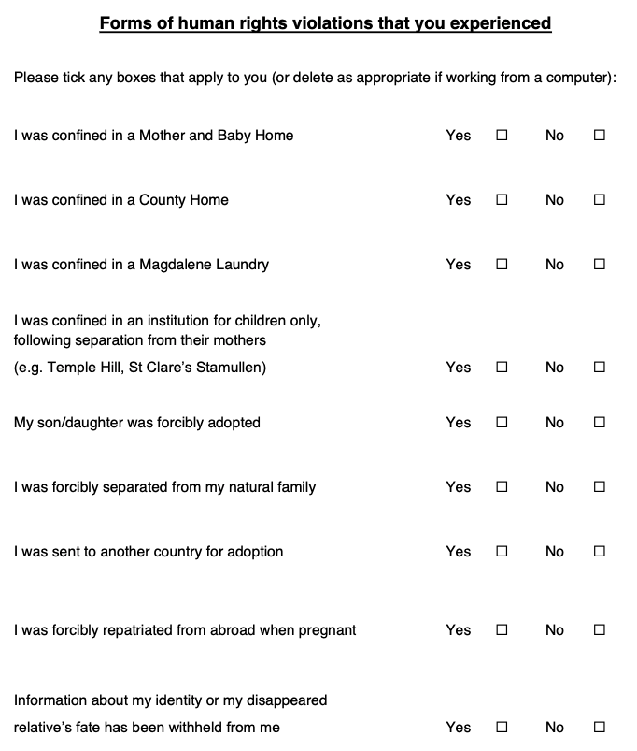

**3.2 How Many Times Can a Person Participate in the EIMBI Survey?**

To all appearances, a person can only participate once in the EIMBI survey. As indicated in **Fig 5**, once a participant has completed the study, if they revisit the [survey website](https://unioflimerick.eu.qualtrics.com/jfe/form/SV_3JgYtlFHkW5FgEK), the system informs them that they have ‘either already completed the survey or your session has expired’ (University of Limerick, 2024f). This presents a significant problem for individuals who are both adopted *and* mothers of children were adopted. As shown in **Fig 2**, participants must state if they are adopted **or** if they are a mother, and they cannot make multiple choices. **Therefore a person who is both adopted and a mother who relinquished her child for adoption cannot complete the survey in both capacities.**

**Fig 5. Message On Website Revisit After Survey Completion**

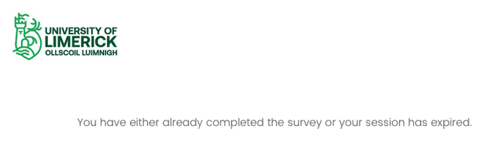

**3.3 Participant Validity**

Notwithstanding the issues highlighted in **Section 3.2**, it is also the case that by clearing the cookies and cache from their browser,[13] a person can begin again and retake the survey. Thus, if a person fits more than one category of participant, technically they can retake the survey if they know that clearing their browser data will be of assistance. However, if it is possible for an individual to take the survey multiple times, this also poses problems for the validity of the research. This is especially the case since the data is gathered anonymously, as indicated in the EIMBI [Volunteer Information Sheet](https://criticaladoptiontheory.com/wp-content/uploads/2025/02/UL-Study_Volunteer-Information-Sheet_Redacted.pdf):

Once you have submitted your responses, you will not be able to withdraw from the study because the survey is anonymous, and we will not be able to identify or remove your individual answers (University of Limerick, 2024g).

**If responses are completely anonymous, this suggests that the researchers have no way of knowing whether the same individual has completed the survey more than once. This poses a significant problem, and could have an impact on the findings of the study.** For example, in 2000, researchers in the United States reported in the *Child Development* journal that ‘more adopted adolescents have problems of various kinds than their nonadopted peers’ (Miller et al., 2000: 1458). According to the authors, adopted adolescents reported ‘more school problems … higher substance abuse, more psychological and health problems’ than their non-adopted counterparts (Miller et al., 2000: 1466). However, two years later the researchers explained that almost twenty percent of adolescents who had completed self-administered questionnaires had falsely represented themselves as adopted people (Fan et al., 2002: 19).[14] These ‘jokesters’ (as the researchers referred to them) were suspected to have ‘given more mischievous or extreme responses on items related to behavioral or psychological problems’. When the ‘jokesters’ were eliminated from the dataset, ‘the differences between the “true” adoptee and non-adoptee groups become very small’ (Fan et al., 2002: 19). In 2003, the researchers rescinded their original findings as reported in the *Child Development* journal (Fan, 2003).

**4. SURVEY QUESTIONS**

**4.1 Survey Questions and the Aims of the EIMBI Study**

We have seen that the EIMBI study aims to ‘document the social, psychological and health needs of those with experiences of Irish Mother and Baby institutions’ and thus, the researchers and their funders are ‘encouraging people to give their views to inform service development and policy’ (University of Limerick, 2024e). While many of the survey questions are relevant to these aims, in the case of others, **it is difficult to understand how they might comprehensively inform any such services.** For example, mothers are asked strangely specific questions (in relation to their lives in general) such as: ‘Have you ever had a very serious accident or accident-related injury (for example, a bad car wreck or an on-the-job accident)?’ (University of Limerick, 2024c). While the researchers may have pertinent reasons for including this question, nevertheless, such a question **may also serve to exclude some participants for whom the question does not apply, but who need services such as mobility aids or home help assistance.** For this reason, disability and related services might be better informed if participants were given multiple choices **regarding the kinds of assistance they require**,such as the examples shown in **Figs 6** and **7**, which aretaken from the [Clann Project Guide](https://clannproject.org/wp-content/uploads/Clann-Project-Guide-to-Restorative-Recognition-Scheme-Consultation_17-03-21.pdf) to the OAK consultation (O’Rourke and McGettrick, 2021: 26-27). (Please see the Clann guide for the full range of prompts.)

**Fig 6. Extract From Clann Guide to Oak Consultation (Part 1)**

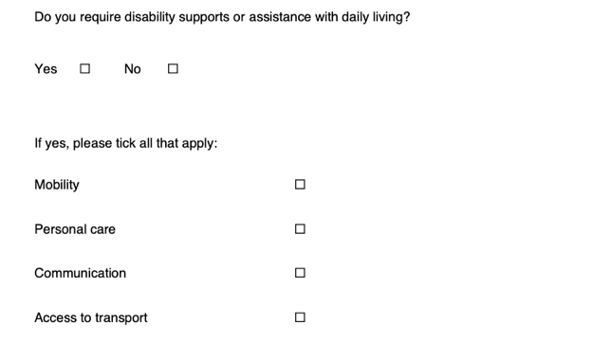

**Fig 7. Extract From Clann Guide to Oak Consultation (Part 2)**

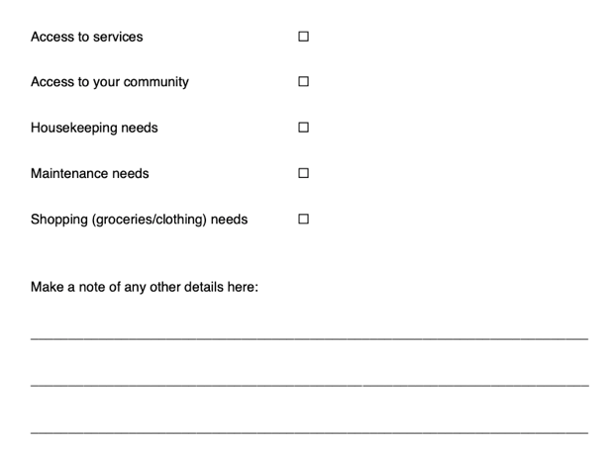

**In some instances, the EIMBI survey questions appear more germane to the subjects of group and national identity.** The EIMBI researchers may have valid reasons for asking these questions, however, the following examples (taken from **Figs 8-10**)seem highly relevant to the SIMTIC project’s aims regarding social identity and group memberships (The GroWTH Lab, 2021a):

* Others who were in a Mother and Baby institution share my beliefs
* I feel detached from others who were adopted through a Mother and Baby institution
* Others who were in a Mother and Baby institution share my burdens
* I’m unhappy about my association with Mother and Baby institutions
* I am glad to be Irish
* Being Irish is an important part of how I see myself (University of Limerick, 2024b; 2024c).

**Fig 8. Extract From EIMBI Survey for Adopted People**

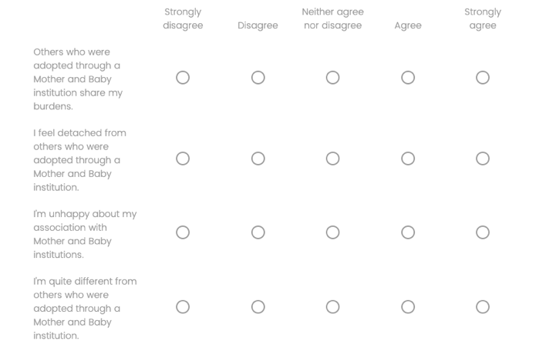

**Fig 9. Extract From EIMBI Survey for Mothers**

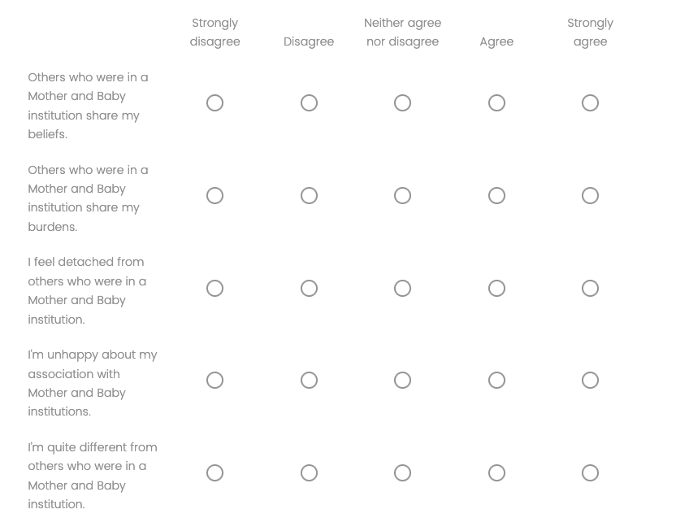

**Fig 10. Extract From EIMBI Surveys for Adopted People and Mothers**

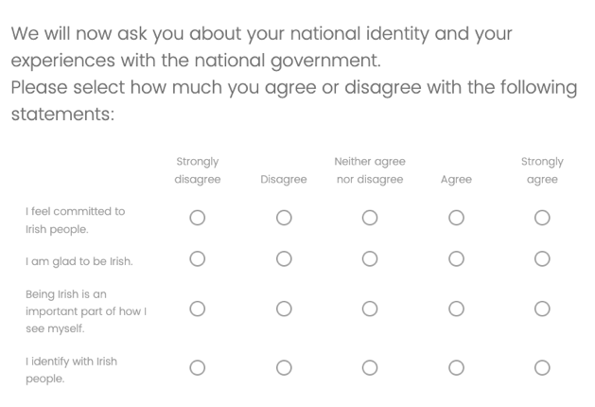

**In some instances, the survey questions are frankly baffling and it is difficult to comprehend how they might usefully inform services in this area.** For example, mothers are asked to rate the extent to which they agree with statements such as: ‘I like being a traditional female’ or ‘I do not want to have equal status with men’ (University of Limerick, 2024c). (See **Fig 11**.)

**Fig 10. Extract From EIMBI Surveys for Mothers**

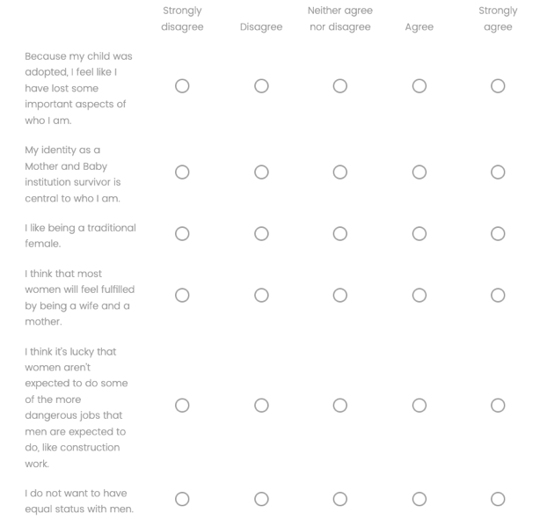

**4.2 Language, Intrusiveness and Excessive Specificity in Survey Questions**

Some questions in the EIMBI survey lack sensitivity and fail to reflect the range of views amongst affected people in relation to the terminology that is used to describe their identities and experiences. For example, adopted people are asked to state the extent to which ‘I identify with my family’ (University of Limerick, 2024b). **However, the question does not specify which family the researchers mean in this instance.** Indeed, later in the same section two further questions are asked about adopted people’s ‘adoptive’ and ‘birth’ families.

**In other examples it seems that the EIMBI survey questions are unnecessarily intrusive, and run the risk of deterring some participants from responding.** For example, in the survey for adopted people, instead of simply asking participants whether they experienced physical, sexual or psychological abuse and/or neglect, the survey asks:

Did an adult or person at least 5 years older than you ever: Touch or fondle you or have you touch their body in a sexual way? Or try to or actually have oral, anal, or vaginal sex with you? (University of Limerick, 2024b).

Some adopted people who experienced such abuses may feel uncomfortable answering such direct questions, particularly since they are only given an option to answer ‘Yes’ or ‘No’ (see **Figs 11** and **12**). The questions regarding psychological and emotional abuse are also unnecessarily specific, for example:

Did a parent or other adult in the household often: Swear at you, insult you, put you down, or humiliate you? Or act in a way that made you afraid that you might be physically hurt?

Did you often feel that: No one in your family loved you or thought you were important or special? Or your family didn’t look out for each other, feel close to each other, or support each other? (University of Limerick, 2024b).

**The preciseness of these questions means that people who experienced emotional or psychological abuse that does not fit these descriptions are not provided with an opportunity to document what happened to them** (for examples of the wide range of experiences of adopted and boarded out people, see O’Rourke and McGettrick et al., 2018: 65-84). As noted above, this is compounded by the fact that only ‘Yes’ or ‘No’ answers are permitted, with no space to provide additional information.

**Fig 11. Extract From EIMBI Survey for Adopted People (Part 1)**

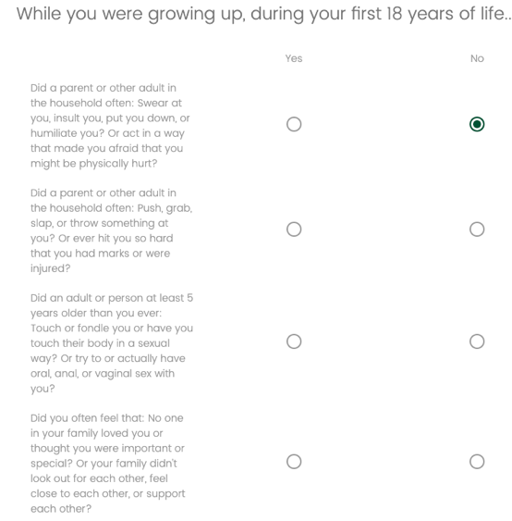

**Fig 12. Extract From EIMBI Survey for Adopted People (Part 2)**

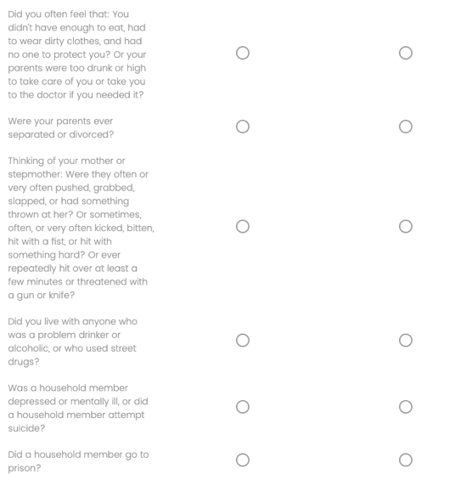

**4.3 Adoption Experiences Are Not Binary**

Adoption is a complex area of study, not least because the experience of being adopted or being a mother is not singular. While adopted people have many commonalities, individual experiences are so variegated in terms of pathways to adoption and adoption experiences, generalisations about adopted people’s psychologies are simply not possible. Similarly, mothers who experienced adoption came from a variety of socioeconomic backgrounds, their circumstances of forced relinquishment (and their associated power relations) were diverse, and their contemporary circumstances are also wide ranging (McGettrick, born Lorraine Hughes, 2024). However, much adoption research which seeks to apply psychological categories frequently fails to grasp these nuances and therefore fails to reflect the range of affected people’s experiences.

For example, in the announcement of the EIMBI study, Kilcommins Greene of the NCS explains that the project aims ‘to create a clearer picture of how people have been affected both *positively and negatively* by their experience’ (University of Limerick, 2024e, emphasis added). This goes some way towards explaining why the EIMBI surveys contain perplexing questions such as ‘I am glad to be someone adopted through a Mother and Baby institution’ (University of Limerick, 2024b).[15] **This question does not capture the complexity of the adoption experience.** For example, in many instances, adopted people feel obliged to report that they have had a positive experience, for fear of appearing disloyal to their adoptive parents, irrespective of what happened to them in childhood and infancy (McGettrick, 2020: 198-199). **Of course, not all adopted people had abusive childhoods, however, this does not justify their separation from their adoptive families and the obliteration of their identities.** For adopted people, navigating such complexities is an integral part of being adopted.

**Moreover, questions such as the example cited above reduce adopted people’s lives to a binary narrative of positive or negative—ergo happy or unhappy—experiences** (McGettrick, born Lorraine Hughes, 2024).[16] To characterise adoption as a mainly happy experience is to belie the innumerable injustices and complexities associated with this institution. Yet, to portray adopted people as inherently and always ‘unhappy’ and therefore psychologically damaged by default because of what happened to them represents a further misapprehension (McGettrick, 2020; 2024). **I contend that a way must be found to acknowledge, study and make legible the injustices and the complexities surrounding adoption without simultaneously pathologising affected people.** (See McGettrick, born Lorraine Hughes (2025a) regarding a proposed alternative theoretical framework.)

**4.4 Reinforcement of Stereotypes and an Insufficient Focus on Truth and Accountability**

Some of the EIMBI survey questions **run the risk of perpetuating inaccurate and damaging stereotypes about adopted people and mothers.** For example, both adopted people and mothers are asked to rate their mental health on a scale of zero to ten, and are asked questions such as: ‘In the last two weeks, how often have you had negative feelings such as blue mood, despair, anxiety, depression?’ (University of Limerick, 2024b; 23024c). (See **Figs 13** and **14**.) From the standpoint of psychological scholars and counselling services, such questions may be important to ask. However, a sociological perspective seeks to understand the structural inequalities that cause mental distress (McGettrick, born Lorraine Hughes, 2024; 2025a; 2025b). For example, in lieu of a response that turns people into ‘suitable cases for treatment’, Nikolas Rose (2020: 32-33) advocates an approach which ‘render[s] a person’s distress intelligible in terms of the challenges of living a life in particular circumstances, and to respond by addressing those challenges’. He argues that ‘this approach requires us to seek solutions to matters such as poverty, debt, inadequate welfare benefits and domestic abuse’. As discussed below, **since access to records and redress are such strong priorities for affected people (Carey, 2024; O’Kennedy, 2021), it is concerning that the EIMBI survey questions about eligibility for the redress scheme and access to records are short, misinformed, and leave no room for nuance or further information.**

**Fig 13. Extract From EIMBI Surveys for Adopted People and Mothers**

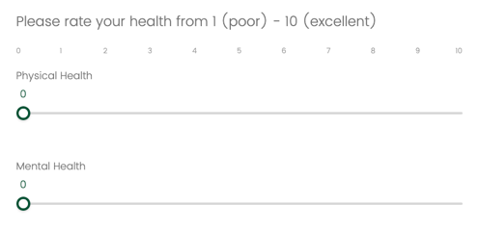

**Fig 14. Extract From EIMBI Surveys for Adopted People and Mothers**

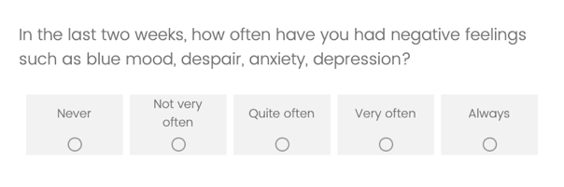

The EIMBI questions on redress and records appear at the end of the survey. As shown in **Fig 15**, in the second last question, participants are asked to confirm if they are eligible for the Mother and Baby Institutions Payment Scheme (University of Limerick, 2024b; University of Limerick, 2024c). However, the available options are wholly inadequate and suggest an apparent lack of insight in this area. For example, participants who are eligible for the scheme are merely asked to confirm if they have applied, if they have received ‘the payment’, or if they have not applied. As demonstrated in the Special Advocate’s press release of September 2024, applicants report significant issues with the scheme, including difficulties with the online portal, a lack of advertising, ‘significant delays, roadblocks, and poor communications’ (Carey, 2024). Moreover, as evidenced with the Magdalene equivalent, the so-called ‘enhanced’ medical card under the scheme does not provide ‘enhanced’ medical supports (JFM Research, 2015). **Thus, given that a primary aim of the EIMBI study is to document health needs, neglecting to ask questions about this aspect of the scheme represents a missed opportunity (University of Limerick, 2024e).**

**EIMBI participants who are not eligible to apply to the redress scheme are offered only one option in the survey: ‘No, I am not eligible’** (University of Limerick, 2024b; University of Limerick, 2024c).[17] When participants click on this response, they are not given an opportunity to provide more information, for example, on the ways they have been excluded or whether they managed to apply. **This omission serves to reinforce the compartmentalisation and exclusion of affected people** **and is especially concerning in light of the fact that this particular area of marginalisation has been specifically highlighted by the Special Advocate:** ‘The myriad exclusions from the scheme have caused deep upset and distress, the further re-traumatisation of some Survivors, and enforced a hierarchy of suffering of Survivors according to arbitrary criteria’ (Carey, 2024).

**Fig 15. EIMBI Survey Question About Mother and Baby Institutions Payment Scheme**

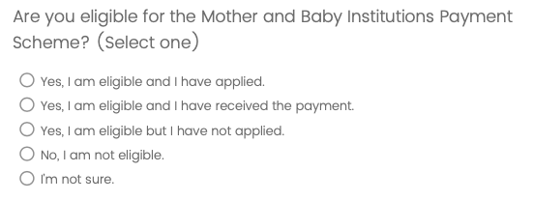

As shown in **Fig 16**, the final question in the EIMBI survey for adopted people concerns the [*Birth (Information and Tracing) Act 2022*](https://www.irishstatutebook.ie/eli/2022/act/14/) *(BITA)* (University of Limerick, 2024b). **The survey for mothers contains no question about the legislation, which is perplexing, since mothers are excluded from *BITA* and may wish to register their dissatisfaction with this exclusion.** The omission is also confusing because mothers are included in other ways in the *BITA* legislation, such as tracing. Additionally, similar to the questions on the redress scheme, the questions concerning *BITA* are also lacking. For example, participants who have received their records are given **no option to explain that documents were withheld from them** (this is not the same thing as ‘receiving no information’)(University of Limerick, 2024b). **Neither are participants given an opportunity to tell the researchers that they had to attend a mandatory Information Session about their parents’ privac**y (see the next section). Moreover, *BITA* is not solely related to obtaining one’s adoption records—the legislation also provides for tracing services and rights for people who were illegally adopted. **Yet, there are no questions in the EIMBI survey that relate to these issues.**

**Fig 16. EIMBI Survey Question About the *Birth (Information and Tracing) Act 2022***

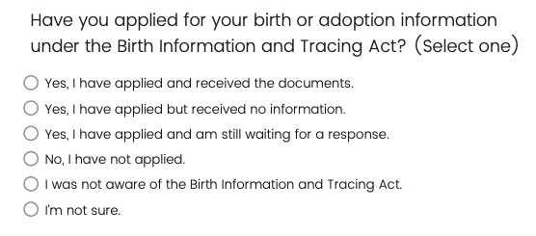

**5. EXPERT KNOWLEDGE AND AFFECTED PEOPLE**

I make the arguments and observations in this paper in large part because I am acutely aware of the extent to which adoption policies and practices are influenced by expert knowledge. Indeed, according to its informational materials, the EIMBI study is being conducted for this very purpose (University of Limerick, 2024e). While we might say that adopted people report being over consulted, there is a dearth of expert knowledge on mothers, particularly in Ireland. I contend that the extant knowledge fails to sufficiently represent mothers’ experiences both past and present (McGettrick, born Lorraine Hughes, 2024). In the case of adopted people, while there are ongoing debates in the field, there is still a widely accepted (though unjustified[18]) view that these individuals are more likely to experience mental and behavioural difficulties than non-adopted people (Herman, 2008: 253; Holmgren et al., 2020: 360). I challenge the veracity of such claims and advocate for an alternative approach to adoption research (McGettrick, born Lorraine Hughes, 2024; 2025a; 2025b).

Although there are significant issues with the accuracy of expert knowledge on adopted people and mothers, **nevertheless, such knowledge has a direct impact on legislation affecting their lives** (McGettrick, born Lorraine Hughes, 2024). For example, the *Birth Information and Tracing Act 2022 (BITA)* provided adopted people with a legal mechanism to access their birth certificates and (some) records (Ireland. *Birth Information and Tracing Act 2022*). However, this access is not automatic; as I argue elsewhere, the legislation also means that:

… adopted people are now categorised as untrustworthy in the eyes of the law – if one or both of our parents register a preference for no contact, their now adult children must attend a mandatory information session about their parents’ privacy rights before the State will give us our own birth certificates (McGettrick, 2022).

Moreover, as discussed above, **the *BITA* legislation excludes mothers,** which is consistent with the misconception that they wish to forget about the past. For example, mainstream discourses frequently characterise adopted people as a threat to their mothers, while mothers are portrayed as fearful of their adult children (e.g., Devlin, 2014; Mahon, 2019). Misapprehensions and inaccuracies in expert knowledge and mainstream discourses not only influence policy, they can also have a bearing how affected people conceptualise themselves. Or, more insidiously, they impact the dominant discourses through which adopted people are expected to make their experiences known (McGettrick, born Lorraine Hughes, 2024; 2025b). **Based on my observations of the EIMBI survey, I have significant concerns about the kinds of expert knowledge that will be constructed from participants’ data.**

**6. CONCLUSION**

This paper has outlined key concerns regarding the EIMBI survey. As outlined in **Section 2**, I consider that the study’s focus on ‘social, psychological and health needs’ runs the risk of creating a misconception that these are the only supports required by affected people (University of Limerick, 2024e). The people affected by ‘historical’ abuses in Ireland are not a homogenous group and their needs are not universal. Equally, I am concerned that the EIMBI is the latest in a long line of consultations with a cohort that is fatigued by such endeavours, particularly because of the lack of delivery (Carey, 2024). Additionally, I am concerned that the EIMBI researchers have not provided sufficient information to participants to enable them to understand the link between the EIMBI study and the SIMTIC project, and I urge them to remedy this without delay. As discussed in **Section 3,** I am concerned that the EIMBI survey is exacerbating existing exclusionary practices in this area, and that it does not go far enough to ensure that the wide range of affected people’s experiences are reflected. Relatedly, as I argue in **Section 4**, the terminology, intrusiveness and needless specificity of some survey questions runs the risk of offending and/or further excluding some participants. In other cases, it is difficult to see how many of the survey questions relate to policy and service provision. In other instances still, the questions reinforce binary perceptions and stereotypes about people affected by ‘historical’ injustices. In general terms, the questions fail to encapsulate the wide range of experiences in this area. While the stated purpose of the EIMBI research is to inform policies and services, I am concerned about how responses to survey questions might also be used to create new knowledge about adopted people and mothers. As discussed in **Section 5**, such knowledge influences policy, and can determine what kind of people the Government considers us to be.

I urge the EIMBI researchers to engage with this analysis and reflect on the questions that it raises. I also hope that legislators and policymakers will take these arguments into account when considering the project’s future findings. The primary audience for this paper are the people who are directly affected by the study and its possible outcomes. **In light of the issues outlined in this analysis, I cannot encourage any affected person to participate in this study, and I recommend that people who have already participated in the project seek clarification from the researchers on any concerns that they have.**

**BIBLIOGRAPHY**

Adoption Rights Alliance (2009) ARA Peer Support Group. Available at: <https://www.facebook.com/groups/adoptionrightsalliance> [Accessed 22nd February 2025].

Carey, P. (2024) *Press Release, 26th September 2024*. Available at: <https://criticaladoptiontheory.com/wp-content/uploads/2025/02/Press-Release-from-the-Special-Advocate-for-Survivors-of-Institutional-Abuse-Patricia-Carey-26.9.2024.pdf> [Accessed 22nd February 2025].[19]

Department of Children, Equality, Disability, Integration and Youth (2024) *Over 12,900 Cases Completed Under Birth Information and Tracing Act*. Available at: <https://www.gov.ie/en/press-release/8bc4f-over-12900-cases-completed-under-birth-information-and-tracing-act/> [Accessed 22nd February 2025].

Devlin, M. (2014) ‘Mothers of Adopted Babies Face a New Trauma if the Cloak of Invisibility is Suddenly Torn Away’, *Irish Independent*, 12th June. Available at: <https://web.archive.org/web/20141004200031/http:/www.independent.ie/opinion/columnists/martina-devlin/mothers-of-adopted-babies-face-a-new-trauma-if-the-cloak-of-invisibility-is-suddenly-torn-away-30348437.html> [Accessed 22nd February 2025].

Fan, X. (2003) ‘Correction to Data and Conclusions’, *Child Development*, 74(3), p. 965.

Fan, X., Miller B.C., Christensen M., Park, K.E., Grotevant H.D., van Dulmen M., Dunbar, N. and Bayley, B. (2002) ‘Questionnaire and Interview Inconsistencies Exaggerated Differences Between Adopted and Non-Adopted Adolescents in a National Sample’, *Adoption Quarterly*, 6(2), pp. 7-27.

Government of Ireland. *Birth Information and Tracing Act.* (2022) Dublin: Stationery Office.

Herman, E. (2008) *Kinship by Design.* Chicago: University of Chicago Press.

Holmgren, E., Raaska, H., Elovainio, M. and Lapinleimu, H. (2020) ‘Behavioral and Emotional Adjustment in Adoptees’, in: Wrobel, G.M., Helder, E. and Marr, E. (eds.) *The Routledge Handbook of Adoption.* Abingdon: Routledge, pp. 353-366.

JFM Research (2015) *JFM Research says Magdalene healthcare provisions are a betrayal of survivors’ trust.* Available at: <https://jfmresearch.com/wp-content/uploads/2017/03/JFMR-PR-140715.pdf> [Accessed 22nd February 2025].

Kim, E. (2010) *Adopted Territory: Transnational Korean Adoptees and the Politics of Belonging.* Durham: Duke University Press.

Mahon, E. (2019) ‘Women Who Gave Up Their Children for Adoption Should Not Be Made to Suffer Twice’, *Irish Times*, 4th July. Available at: <https://www.irishtimes.com/opinion/women-who-gave-up-their-children-for-adoption-should-not-be-made-to-suffer-twice-1.3945606> [Accessed 22nd February 2025].

McGettrick, C. (2023a) ‘Adoption Social Work Practice in Ireland: Critical Reflections on Present-Day Injustices’, in: Ioakimidis, V. and Wyllie, A. (eds.) *Social Work’s Histories of Complicity and Resistance: A Tale of Two Professions.* Bristol: Policy Press, pp. 261-277.

McGettrick, C. (2023b) [Twitter] 9th March. Available at: <https://x.com/cmcgettrick/status/1633927604603428866> [Accessed 22nd February 2025]. [Archived at: <https://criticaladoptiontheory.com/wp-content/uploads/2025/02/CMcGLH_Twitter-Thread-Re-Special-Advocate.pdf>]

McGettrick, C. (2022) ‘Last Week, Birth Information Became Accessible—But the Law Doesn't Go Far Enough’ *thejournal.ie*, 11th October. Available at: <https://www.thejournal.ie/readme/irish-adoption-law-5889223-Oct2022/> [Accessed 22nd February 2025].

McGettrick, C. (2020) [‘”Illegitimate” Knowledge: Transitional Justice and Adopted People’](https://muse.jhu.edu/article/763494/summary), *Éire-Ireland*, vol. 55 (1), 2020, pp. 181-200.

McGettrick, born Lorraine Hughes, C. (2025a) *About Critical Adoption Theory*. Available at: <https://criticaladoptiontheory.com/cat/> [Accessed 22nd February 2025].

McGettrick, born Lorraine Hughes, C. (2025b) *Making Up Adopted People*. Available at: <https://criticaladoptiontheory.com/makingupadoptedpeople/> [Accessed 22nd February 2025].

McGettrick, born Lorraine Hughes, C. (2024) *Making Up Adopted People: Pathologisations in Adoption Psychology and the Shaping of Adoption Policies and Identities.* PhD Dissertation. University College Dublin.

McGettrick, C., O’Donnell, K., O’Rourke, M., Smith, J.M. and Steed M. (2021) *Ireland and the Magdalene Laundries: A Campaign for Justice.* London: IB Tauris/Bloomsbury.

McGettrick, C. and O’Rourke, M. (2021) Clann Project Submission to Oak Consulting Re: Consultation Process on the Development of an Ex-Gratia ‘Restorative Recognition Scheme’. Available at: <https://clannproject.org/restorative-recognition-scheme/clann-project-recommendations-on-restorative-recognition-scheme/> [Accessed 22nd February 2025].

Miller, B.C., Fan, X., Christensen, M., Grotevant, H.D. and van Dulmen, M. (2000) ‘Comparisons of Adopted and Nonadopted Adolescents in a Large, Nationally Representative Sample’, *Child Development,* 71(5), pp. 1458-1473.

Moroney, D., O’Donnell, A., O’Connor, M., and Muldoon, O.T. (2025) ‘[Adoption and Social Identity Loss: Insights From Adults Adopted Through Ireland's Mother and Baby Homes](https://bpspsychub.onlinelibrary.wiley.com/doi/10.1111/bjso.12869)’, *British Journal of Social Psychology*, *64*, e12869.

O’Donnell, K., Pembroke, S. and McGettrick, C. (2013) *Magdalene Institutions: Recording an Oral and Archival History.* Available at: <http://jfmresearch.com/home/oralhistoryproject/> [Accessed 22nd February 2025].

O’Kennedy, M.L. (2021) *Report of the Findings of the Consultation with Survivors of Mother and Baby Homes and County Homes*. Available at: <https://assets.gov.ie/285098/65cf6ce2-a60b-432b-abc5-cbbc9b7a6162.pdf> [Accessed 22nd February 2025].

O’Rourke, M. and McGettrick, C. (n.d.) *Clann: Ireland’s Unmarried Mothers and their Children: Gathering the Data.* Available at: <http://clannproject.org> [Accessed 22nd February 2025].

O’Rourke, M. and McGettrick, C. (2021) *Clann Project Guide to Assist Those Who Wish to Contribute to the Government’s Call for Submissions on a ‘Restorative Recognition Scheme’.* Available at: <https://clannproject.org/wp-content/uploads/Clann-Project-Guide-to-Restorative-Recognition-Scheme-Consultation_17-03-21.pdf> [Accessed 22nd February 2025].

O’Rourke, M., McGettrick, C., Baker, R. and Hill, R. (2018) *Clann: Ireland’s Unmarried Mothers and their Children: Gathering the Data: Principal Submission to the Commission of Investigation into Mother and Baby Homes*. Dublin: Justice for Magdalenes Research, Adoption Rights Alliance, Hogan Lovells. Available at:<http://clannproject.org/wp-content/uploads/Clann-Submissions_Redacted-Public-Version-October-2018.pdf> [Accessed 22nd February 2025].

Rose, N. (2020) ‘Social Suffering’, *RSA Journal,* 166(2) (5582), pp. 30-33.

The GroWTH Lab (2023) [Twitter] 21st April. Available at: <https://x.com/growth_ul/status/1649336079818817537> [Accessed 22nd February 2025]. [Archived at: <https://criticaladoptiontheory.com/wp-content/uploads/2025/02/UL-Tweet.pdf>]

The GroWTH Lab (2021a) *About Us*. Available at: <https://growth-ul.wixsite.com/psychology/current-projects> [Accessed 22nd February 2025].

The GroWTH Lab (2021b) *Current Projects*. Available at: <https://growth-ul.wixsite.com/psychology/current-projects> [Accessed 22nd February 2025].

University of Limerick (2024a) *EIMBI Ethical Consent Form.* Available at: <https://criticaladoptiontheory.com/wp-content/uploads/2025/02/UL-Study_Survey_Adopted-People.pdf> [Accessed 22nd February 2025].

University of Limerick (2024b) *EIMBI Survey Questions (Adopted People).* Available at: <https://criticaladoptiontheory.com/wp-content/uploads/2025/02/UL-Study_Consent-Form.pdf> [Accessed 22nd February 2025].

University of Limerick (2024c) *EIMBI Survey Questions (Mothers).* Available at: <https://criticaladoptiontheory.com/wp-content/uploads/2025/02/UL-Study_Survey_Mothers.pdf> [Accessed 22nd February 2025].

University of Limerick (2024d) *UL Academic Wins 2024 European Research Council Public Engagement Award.* Available at: <https://www.ul.ie/news/ul-academic-wins-2024-european-research-council-public-engagement-award> [Accessed 22nd February 2025].

University of Limerick (2024e) *University of Limerick Launches Major New Study n Experiences of Irish Mother and Baby Institutions*. Available at:

<https://www.ul.ie/news/university-of-limerick-launches-major-new-study-on-experiences-of-irish-mother-and-baby> [Accessed 22nd February 2025].

University of Limerick (2024f) *EIMBI Online Survey*. Available at:

<https://unioflimerick.eu.qualtrics.com/jfe/form/SV_3JgYtlFHkW5FgEK> [Accessed 22nd February 2025].

University of Limerick (2024g) *EIMBI Volunteer Information Sheet.* Available at: <https://criticaladoptiontheory.com/wp-content/uploads/2025/02/UL-Study_Volunteer-Information-Sheet_Redacted.pdf> [Accessed 22nd February 2025].

1. ERC Advanced Grants provide long-term funding to large research projects. See: <https://erc.europa.eu/apply-grant/advanced-grant>. For further discussion see **Section 2.2.** I wish to acknowledge that Dearbhla Moroney, one of the researchers, contacted me to share a recent article about the project (Moroney et al., 2025), and generously acknowledged my work.
2. See McGettrick, born Lorraine Hughes (2025a) or [click here](https://criticaladoptiontheory.com/cat/) for further information.
3. Due to copyright issues, it is not possible to hyperlink all materials. If you are a person affected by the issues discussed in this paper and you do not have access to a book or article referenced in this document, please email [info@criticaladoptiontheory.com](mailto:info@criticaladoptiontheory.com) to request a copy of the article or chapter.
4. Formerly Justice for Magdalenes (JFM).
5. See: O’Donnell, Pembroke and McGettrick, 2013; O’Rourke and McGettrick, n.d.; McGettrick, O’Donnell, O’Rourke, Smith, and Steed, n.d.; McGettrick, O’Donnell, O’Rourke, Smith, and Steed, 2021.
6. Membership is restricted to people directly affected by adoption and forced family separation in Ireland, and at present, the group has over 3,000 members.
7. The Clann recommendations are informed by witness statements and other evidence, human rights analysis, our experience in assisting people affected by myriad injustices over two decades (McGettrick and O’Rourke, 2021: 2).
8. The full list of Clann recommendations is as follows:

   Access to records legislation

   HAA Medical Card

   Recommendations regarding the compensation process in a ‘Restorative Recognition Scheme’

   Implementation of the Mother and Baby Homes Collaborative Forum Recommendations

   Explicit rights for people adopted overseas

   Proper implementation of EU GDPR rights

   Access to court

   Dedicated Criminal Justice Unit & Human Rights-Compliant Coroner’s

   Inquests

   Repeal of ‘gagging’ orders

   Amendment of the Status of Children Act 1987

   Official acknowledgement of human rights violations
9. I am [critical](https://criticaladoptiontheory.com/wp-content/uploads/2025/02/CMcGLH_Twitter-Thread-Re-Special-Advocate.pdf) of the Government’s exclusionary terminology and terms of reference for the role of Special Advocate (see McGettrick, 2023b). Fortunately, although the Government’s terminology is exclusionary, the Special Advocate’s office is open to all affected people.
10. The project’s full title is: ‘A Social Identity Model of Trauma and Identity Change: A Novel Theory of Post-Traumatic Stress, Resilience and Growth’.
11. Surveys are an example of quantitative research methods.
12. This guide was adapted from the [*JFM Guide to the Magdalen Commission*](http://jfmresearch.com/wp-content/uploads/Survivor-Guide-to-Magdalen-Commission.pdf). The Magdalen Commission was led by Mr Justice John Quirke, who was appointed by the Government to undertake a review and make recommendations on a redress scheme. The JFM guide was designed to help survivors in making an account of their current needs and their experiences.
13. For an explanation of what this means see: <https://ie.norton.com/blog/how-to/clear-cache-and-cookies>.
14. The researchers obtained their data from the National Longitudinal Study of Adolescent Health, which included self-administered questionnaires and at-home interviews.
15. Mothers are also asked to state the extent to which they are: ‘glad to be a mother with experience of a Mother and Baby institution’ (University of Limerick, 2024c).
16. See also discussion in see discussion in Kim (2010: 9).
17. A final option states: ‘I’m not sure’.
18. See McGettrick, born Lorraine Hughes (2024).
19. This press release is provided via [criticaladoptiontheory.com](http://www.criticaladoptiontheory.com/) as the Special Advocate’s office does not currently have a website.